 | On the beat in…  North Shropshire  Market Drayton  Wem  Whitchurch  Safer Neighbourhood Team Newsletter | April  2026

Current statistics on calls to police and crime recording for your neighbourhood can be found at www.police.uk. If you wish to discuss further, please contact a member of your Safer Neighbourhood Team.

Market Drayton – Team contact details:
Team email: marketdrayton.snt@westmercia.police.uk
Safer Neighbourhood Officer: PC Iain McIntosh Mobile: 07811 748 732
Safer Neighbourhood Officer: PC Tom Rayment Mobile: 07977 957 718
Police Community Support Officer: PCSO Steve Robinson Mobile: 07870 218 709
Police Community Support Officer: PCSO Tara Carruthers Mobile: 07971 050 442
Police Community Support Officer: PCSO Richard Parker Mobile: 07483 123 858

Wem – Team contact details:
Team email: wem.snt@westmercia.police.uk
Safer Neighbourhood Officer: PC Jack Harper Mobile: 07817 885 113
Safer Neighbourhood Officer: PC Mark Holtschke Mobile: 07971 051 201
Police Community support Officer: PCSO Lizz Walmsley Mobile: 07967 303 567
Police Community support Officer: Vacant Mobile: TBC

Whitchurch – Team contact details:
Team email: whitchurch.snt@westmercia.police.uk
Safer Neighbourhood Officer: PC Mark Bates Mobile: 07900 607 965
Police Community Support Officer: PCSO Jamie Robinson Mobile: 07967 301 147
Police Community Support Officer: PCSO Dave Andrew Mobile: 07971 395 050
Police Community Support Officer: PCSO Sarah Parker Mobile: 07483 121 957

Reporting A Crime

Is it an emergency?

Call 999 in emergency situations like these:

- there is an immediate danger to life
- someone is using violence or is threatening to be violent
- a crime is happening right now, like a house burglary or a theft
- the suspect is still at the scene

If it's not an emergency

If you’ve witnessed or been the victim of crime that isn't an emergency, please report it to us.

Your report will be sent direct to our control room. Before you give us the details of the crime, we'll ask you a few questions to make sure you go to the right online form.
www.westmercia.police.uk/ro/report/ocr/af/how-to-report-a-crime/

Please encourage your parishioners to sign up to Neighbourhood Matters…

Neighbourhood Matters enables residents, businesses, and community groups to keep in touch with local policing teams. You can choose exactly what type of alert you wish to receive and how you receive them; whether that be by email, text or telephone.
Sign up now at: www.neighbourhoodmatters.co.uk

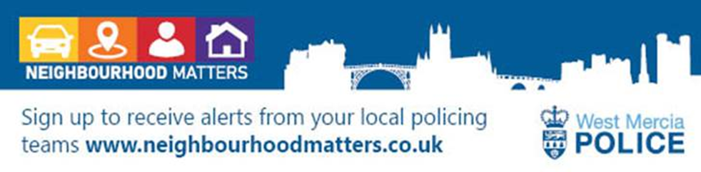

Hello Parish Councils,

This is your North Shropshire Safer Neighbourhood Team (SNT) Newsletter for April 2026. Please see the link above to police.uk for crime recording statistics for your area, or any other area in the UK should you wish.

Please get in touch if you would like to discuss anything further, if we can provide more information we will, our contact details are above. If there is anything specific that is affecting your parish area above and beyond the three priorities you have nominated, again please let us know and we will endeavour to support you.

The official West Mercia Police website www.westmercia.police.uk has a wealth of information and includes dedicated sections in relation to News, Recruitment, Watch Schemes, Neighbourhood Matters, Crime Prevention Advice, Support For Victims, other Advice and Information and Thanks & Complaints.

Our North Shropshire SNTs work in a very challenging and varied role and no two days are the same, naturally there are many requests for our time, support and assistance. Obviously, much of what we do we can’t tell you too much about, but rest assured that much of our focus is on the three Parish Council Priorities that you provide us with quarterly.

Much of the good work that SNTs engage with are posted in the following places:

- Parish Council attendance in person or North Shropshire SNT Newsletters

- Neighbourhood Matters – www.neighbourhoodmatters.co.uk

- Facebook - www.facebook.com/MktDraytonPolice (North Shropshire specific)

www.facebook.com/westmerciapolice

www.facebook.com/WMPRuralMatters

North Shropshire Safer Neighbourhood Team’s mobile police station events for April:

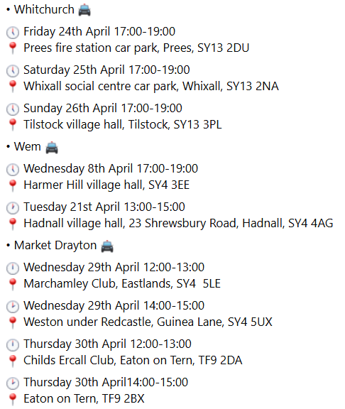

Below is just a small snapshot of the good work North Shropshire SNTs have been involved with recently…

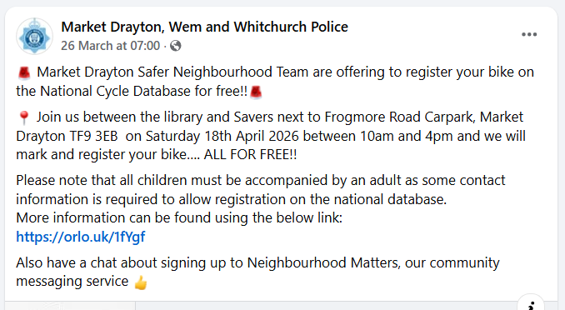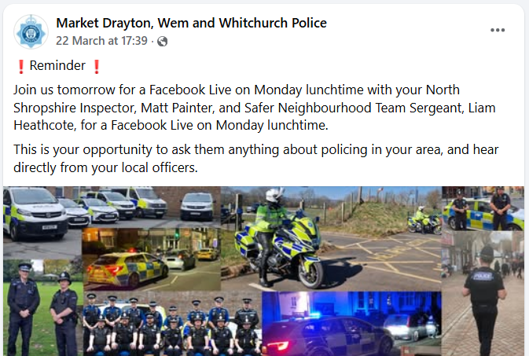

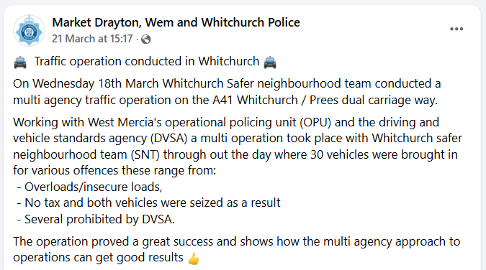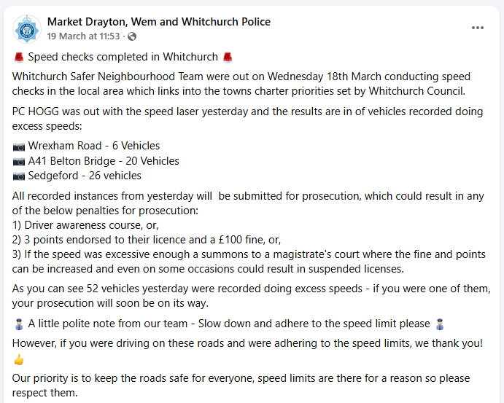

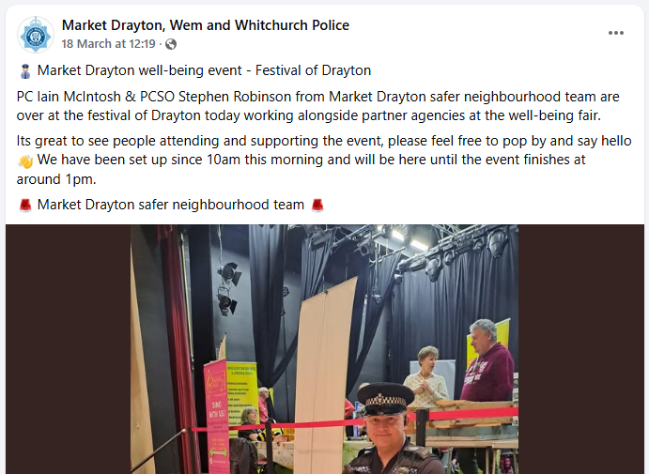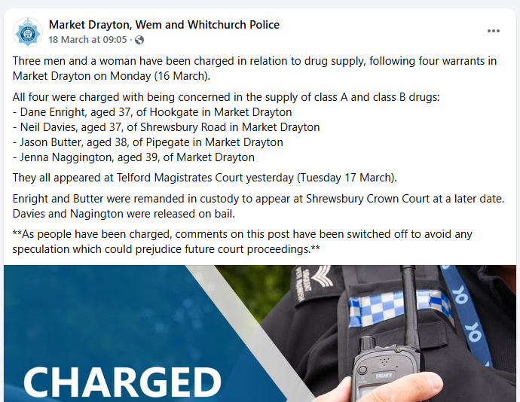

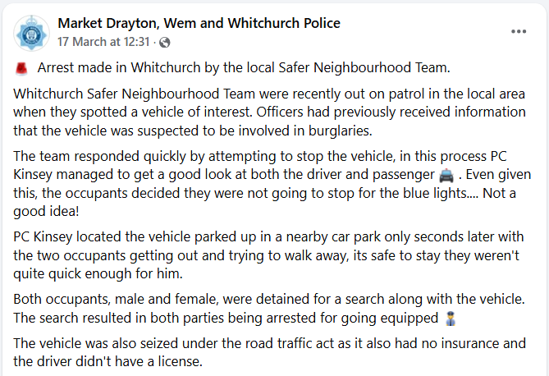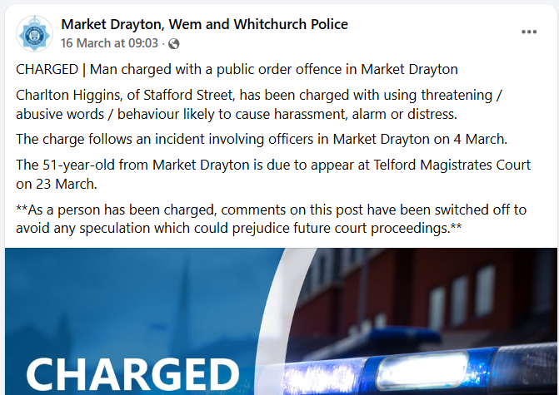

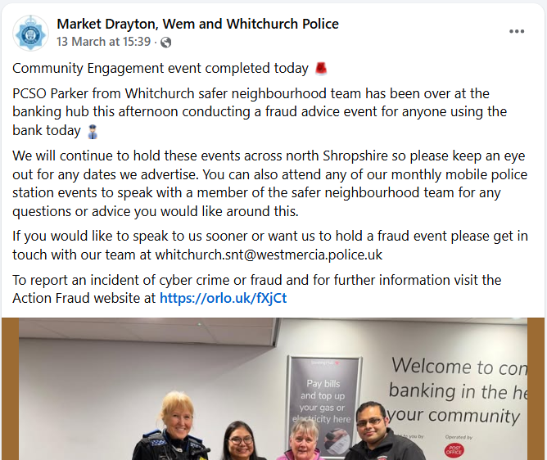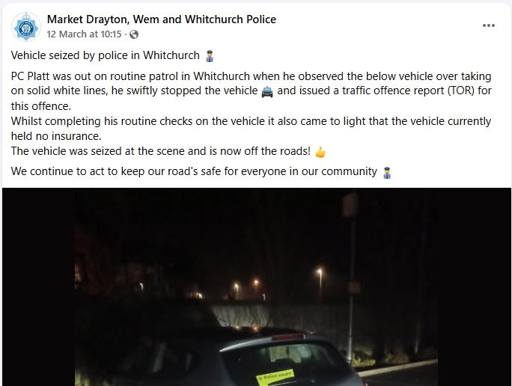

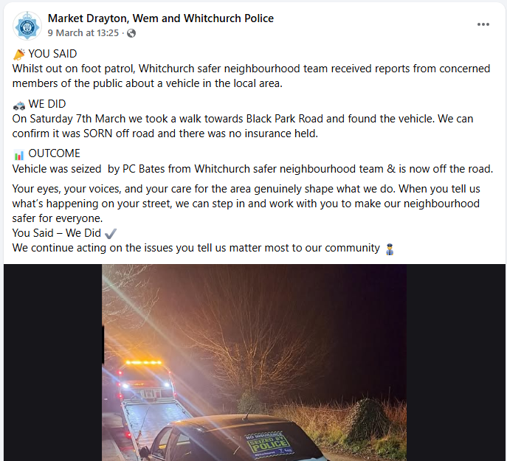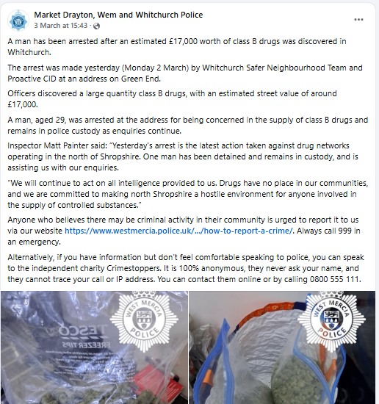
As part of the monthly Newsletter, we will be adding trending and/or appropriate crime prevention advice and information. Along with any recent updates from our other policing departments and partners.

This month’s Newsletter contains information on;

- West Mercia Police Ride Along Scheme
- Are you aware of Community Speed Watch, and is it relevant to your parish?
- ‘Operation Snap’
- ‘WalkSafe’ – Personal safety app
- ‘Crimestoppers’ & ‘Fearless’
- ‘Report Fraud’
- The Victim Support Gateway
- ‘SmartWater’

West Mercia Police Ride Along Scheme

Ever wondered what it's really like to work in your community, tackling local issues and keeping people safe day to day? Now's your chance to find out!

Earlier this week, West Mercia Police relaunched the Ride Along scheme across Herefordshire, Shropshire and Worcestershire, giving you the opportunity to join a neighbourhood officer on patrol and see what policing is like in your area.

During your Ride Along, you'll:
Experience what a typical shift looks like for a neighbourhood officer
Chat with officers about local policing and community priorities
- See first-hand how neighbourhood teams work to resolve issues or concerns in your local area

The Ride Along scheme is open to anyone aged 18 or over, and you must live in Herefordshire, Shropshire or Worcestershire.

Whether you are considering a career in policing, would like to know how your local area is being policed, or simply have an interest in policing, you are invited on shift.

Visit https://orlo.uk/97GAY to find out more.

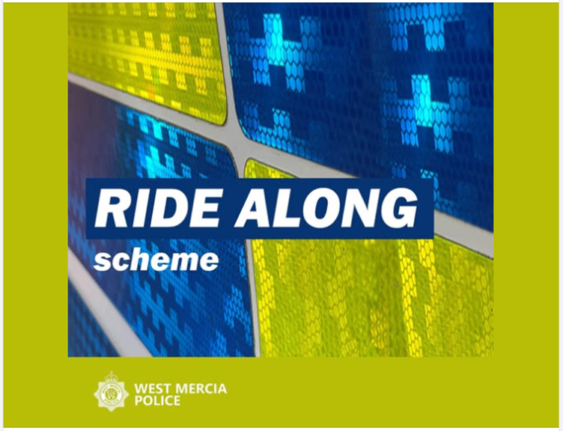

Are you aware of Community Speed Watch, and is it relevant to your parish?

With Community Speed Watch now in its eighth year of operation within West Mercia, local communities are being reminded about the scheme and how volunteers can get involved in speed monitoring and improve the quality of life in their area if speeding traffic is causing concern.
Community Speed Watch is a community driven road safety initiative, coordinated by West Mercia Police but managed and run by volunteers in the community. It involves trained volunteers from the community monitoring the speeds of vehicles with approved, hand-held speed measurement devices. Where vehicle speeds are found to be inappropriate, a letter is sent to the registered keeper by the police with the aim of encouraging them to reduce their speed when driving in the future.
The scheme was introduced within West Mercia in 2014 and has gone from strength to strength over the last 8 years with over 40 active sites currently operating. It was introduced to enhance the force’s speed enforcement strategy, by addressing community concerns in areas that do not meet either speed or collision criteria for police-led enforcement.

A Community Speed Watch scheme is initiated when ‘speeding traffic’ has been identified as a community road safety concern by a parish council or Safer Neighbourhood Team. However, several criteria must be met before a scheme can be established:
- The area must have a 30mph or 40mph speed restriction.
- Speed data collected by West Mercia Police must show that speed levels in the area do not meet the national industry requirements for police enforcement.
- No other enforcement activity is currently in place.
- There must be at least six volunteers in each Community Speed Watch scheme.
- Speed checks must be conducted by at least three volunteers at any one time.

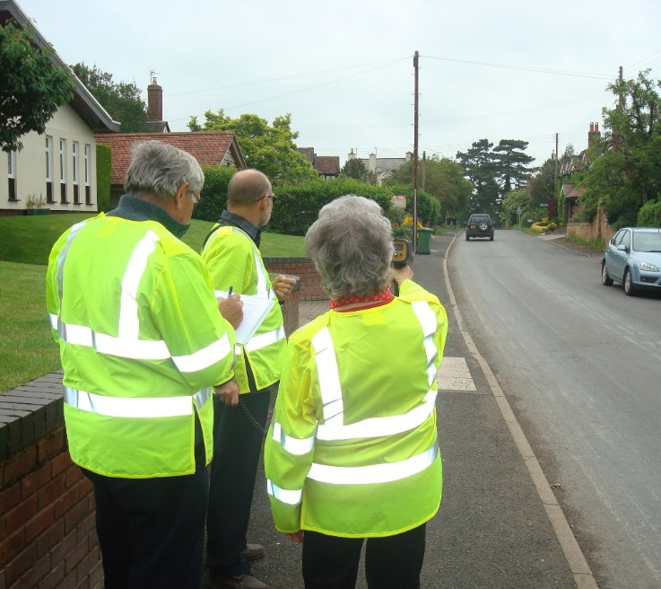

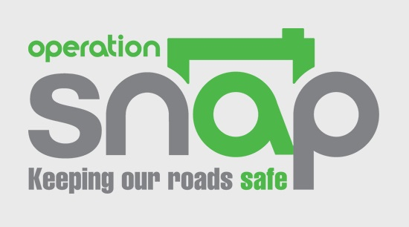

As part of Operation Snap, members of the public can report and submit digital footage showing potential traffic offences via a secure online form.

https://secureform.nextbase.co.uk/

This can range from driving dangerously or carelessly to overtaking on solid white lines, using a mobile phone while driving, ignoring traffic lights or dangerous driving around other road users, such as horse riders and cyclists.

Please note; issues with number plates, windscreens and minor traffic offences are unable to be dealt with via Op Snap.

General parking complaints (other than illegal parking on zig zags) should be raised with the relevant local authority. Notification of untaxed vehicles can be reported directly to DVLA, reports of no MOT or no insurance should be logged to 101, not via the Op Snap portal.

Your submission will be sent to West Mercia Police where the evidence will be reviewed by one of our road traffic police officers.

One statement is required for each submission/offending vehicle. We are unable to process multiple offences sent as one submission.

We will strive to update each submitter regarding the outcome of their allegation. All submissions are dealt with pro-actively to help reduce risk taking and poor driving on our counties roads.

Any footage submitted through the portal can be used by us to help educate other road users and to advise on case results.

Please note - if you operate a recording device in a public place, you may have obligations under the General Data Protection Regulation (GDPR). It is in your interest to familiarise yourself, and comply with, any such obligations as apply to you. If you are in any doubt as to your obligations, please obtain independent legal advice to ensure you do not put yourself at risk of prosecution. By submitting footage you acknowledge you have read and understood this before proceeding.

For more information, please see the Frequently Asked Questions section or email OpSnap@westmercia.police.uk

‘WalkSafe’ - Personal safety app launched across West Mercia

West Mercia Police has launched a personal safety app, which aims to help people feel more confident when out and about during the busy festive period.

WalkSafe is available to people across Herefordshire, Shropshire and Worcestershire and provides users with a list of safety-trained venues, including bars, restaurants and other premises that meet recognised standards through schemes such as Licensed Security & Vulnerability Initiative (LSAVI) and Best Bar None.

The app also allows people to plan their route home, share their journey with trusted friends or family and make use of an SOS alert button if they feel unsafe.

The introduction of WalkSafe across West Mercia supports ongoing work to improve safety in public spaces, particularly for women and girls.

WalkSafe is backed by West Mercia’s Police and Crime Commissioner and is funded through the Home Office. It will be available all year round.

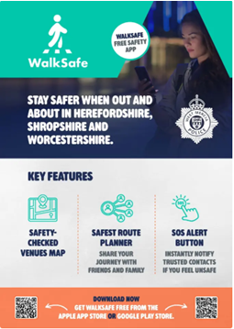

The contacts below may be of interest to those in the parish who may be more comfortable reporting crime or giving information to the police, anonymously:

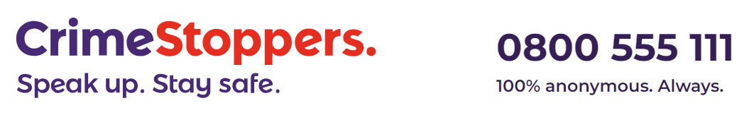
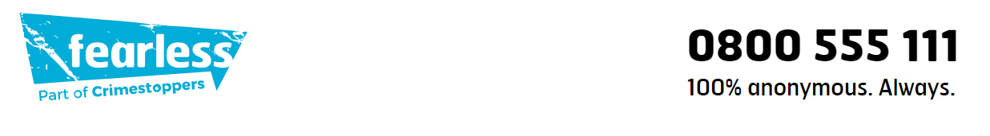

Are your parishioners aware of Report Fraud?



www.reportfraud.police.uk

0300 123 2040

There is now a new national cyber crime and fraud service called Report Fraud.

This replaces Action Fraud, which has been around since 2009, and is completely new service for reporting and responding to cyber crime and fraud. It will provide an end-to-end service, from how reports of cyber crime and fraud can be made, to how reports are analysed and how victims are supported.

Report Fraud has been designed and delivered by the City of London Police, who are the national policing lead for fraud, in close partnership with the National Crime Agency along with banking, tech and victim services.

How does Report Fraud differ from Action Fraud?

- Law enforcement agencies will be able to share data to and / or from the new service.

- The new service will assist in taking down websites, bank accounts and other channels through which criminal activity takes place.

- It will provide specialist advice and support to victims of crime.

- Be able to take forward investigations into reports of criminal activity.

- Use trends on threats at international, national, regional and local level.

Report Fraud will:

- Make it easier for anyone from any background or demographic to report cyber crime and fraud.

- Inform victims about what has happened or is happening with their report.

- Quickly and efficiently inform victims when their crime report has contributed towards the protection of others.

- Protect a greater number of people and businesses from the risk of cyber crime and fraud through delivery of targeted and timely advice on how to avoid the latest threats.

- Significantly improve the speed and quality of information provided to law enforcement partners, boosting their chances of successful prosecutions.

- Block and disrupt crime through providing real-time information to those institutions and organisations who can deter and disrupt fraudulent websites, bank accounts, and other activities enabling criminality.


The Victim Support Gateway

The Victim Support Gateway is a free and confidential support service available to anyone in Herefordshire, Shropshire, Telford & Wrekin or Worcestershire who has been affected by crime.
You'll have a named point of contact to help you with a range of services including:

- emotional support
- practical help
- help to navigate the criminal justice system
- support in dealing with services such as housing and insurance
- access to specialist support services
- personal safety advice and equipment

The Victim Support Gateway can be contacted via:

Telephone: 01905 726 896
Email: VictimSupportGateway@victimsupport.org.uk
24/7 Live Chat: Live chat




